DAY 20 REPORT
Data Analytics, Inspect Element and CanvasJS
Introduction
Websites such as YouTube and LinkedIn use data analytics extensively to monitor user activities and identify countable patterns.

1.Data Analytics in YouTube
Website:
YouTube
YouTube uses data analytics to analyze user viewing behavior and improve recommendations.
Data Collected:
- Video views
- Likes and comments
- Watch time
- Search history
- Subscriber count
Countable Patterns:
- Trending videos
- Most viewed categories
- User interests
- Peak watching hours
Example:
If many users repeatedly watch cricket highlights, YouTube detects the pattern and recommends similar videos.

2.Data Analytics in LinkedIn
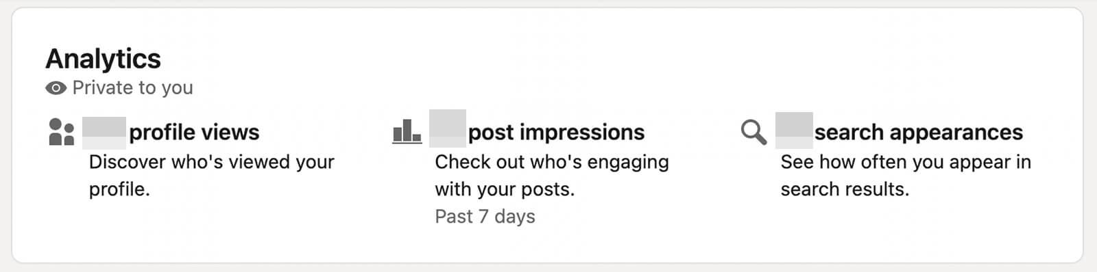

Website:
LinkedIn
LinkedIn uses data analytics to monitor professional activities and recruitment trends.
Data Collected:
- Profile views
- Job searches
- Skills and endorsements
- Connections
- Post engagement
Countable Patterns:
- Most searched skills
- Hiring trends
- User engagement
- Job application frequency
Example:
If many users search for “Python Developer,” LinkedIn identifies the trend and recommends related jobs.

TASK - CanvasJS Task
Introduction
CanvasJS is a JavaScript library used to create charts and graphs for data visualization. In this task, CanvasJS was used to create and analyze charts such as line charts and pie charts.
Website
CanvasJS Official Website

Objectives of the Task
- To understand data visualization using CanvasJS
- To create charts using JavaScript
- To analyze chart rendering in browser Developer Tools
- To convert a line chart into a pie chart
- To verify chart loading using the Network section

Uses of CanvasJS
CanvasJS is used for:
- Displaying analytics
- Creating dashboards
- Visualizing patterns
- Showing statistical data

How to Open Inspect Element for CanvasJS
Step 1: Open CanvasJS Website
Open the CanvasJS chart webpage in browser.

Step 2: Right Click on the Chart Page
Right click anywhere on the webpage containing the CanvasJS chart.
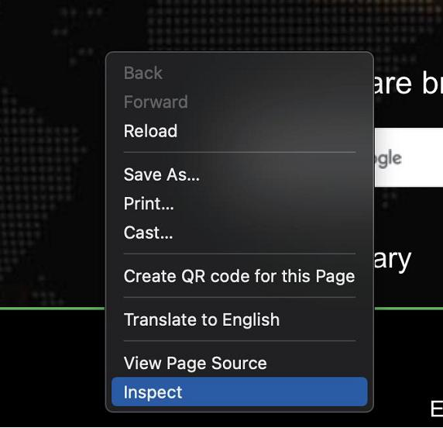

Step 3: Open Network Tab
Click the Network tab inside Developer Tools.
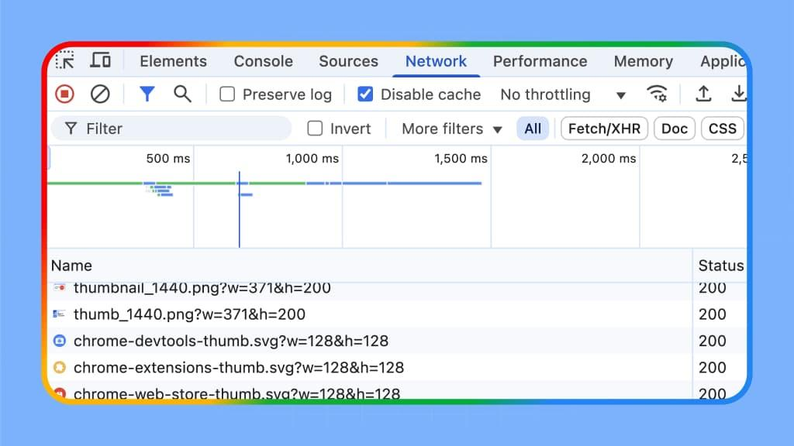

Step 4: Refresh the CanvasJS Page
Refresh the webpage to load chart requests and resources.

Step 5: Check CanvasJS Request Status
Find:
canvasjs.min.js
and check the Status column.
Successful Status:
- 200 OK
- 304 Not Modified
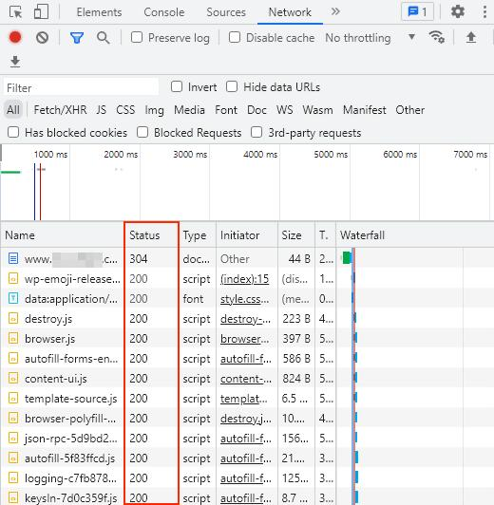

Types of Charts Used
1. Line Chart
A line chart displays continuous trends and changes over time.
Example:
type: "line"
Applications:
- Sales growth analysis
- Website traffic monitoring
- Student marks analysis
- Performance tracking

2. Pie Chart
A pie chart displays percentage-based data in circular form.
Example:
type: "pie"
Applications:
- Survey analysis
- Percentage comparison
- Market share analysis
- Student result distribution

Conversion of Line Chart into Pie Chart
The line chart was converted into a pie chart by modifying the chart type property.
Changed From:
type: "line"
Changed Into:
type: "pie"
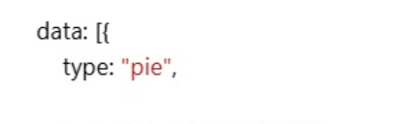
This conversion changed the graphical representation from connected lines into circular slices.

Checking Chart Status in Network Section
The Network section in Inspect Element was used to verify whether the chart and resources loaded successfully.
Steps Performed:
- Opened Inspect Element
- Opened the Network tab
- Refreshed the webpage
- Checked the Status column
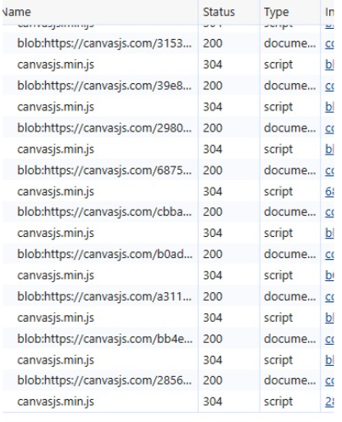

Status Codes Observed
Status Code | Meaning
200 | Request successful
304 | Not Modified (loaded from cache)
404 | File not found
500 | Internal server error

Conclusion
This task helped in understanding how CanvasJS is used for data visualization and chart creation. Different chart types such as line charts and pie charts were analyzed and modified. The Network section in Developer Tools was used to verify successful loading of chart resources using status codes such as 200 and 304.

